Resetting Password

Forgot your password? Not to worry.

Follow the steps below to reset your password quickly and securely.

Step 1:
On the login screen, click the “Forgot Password” link as shown below.
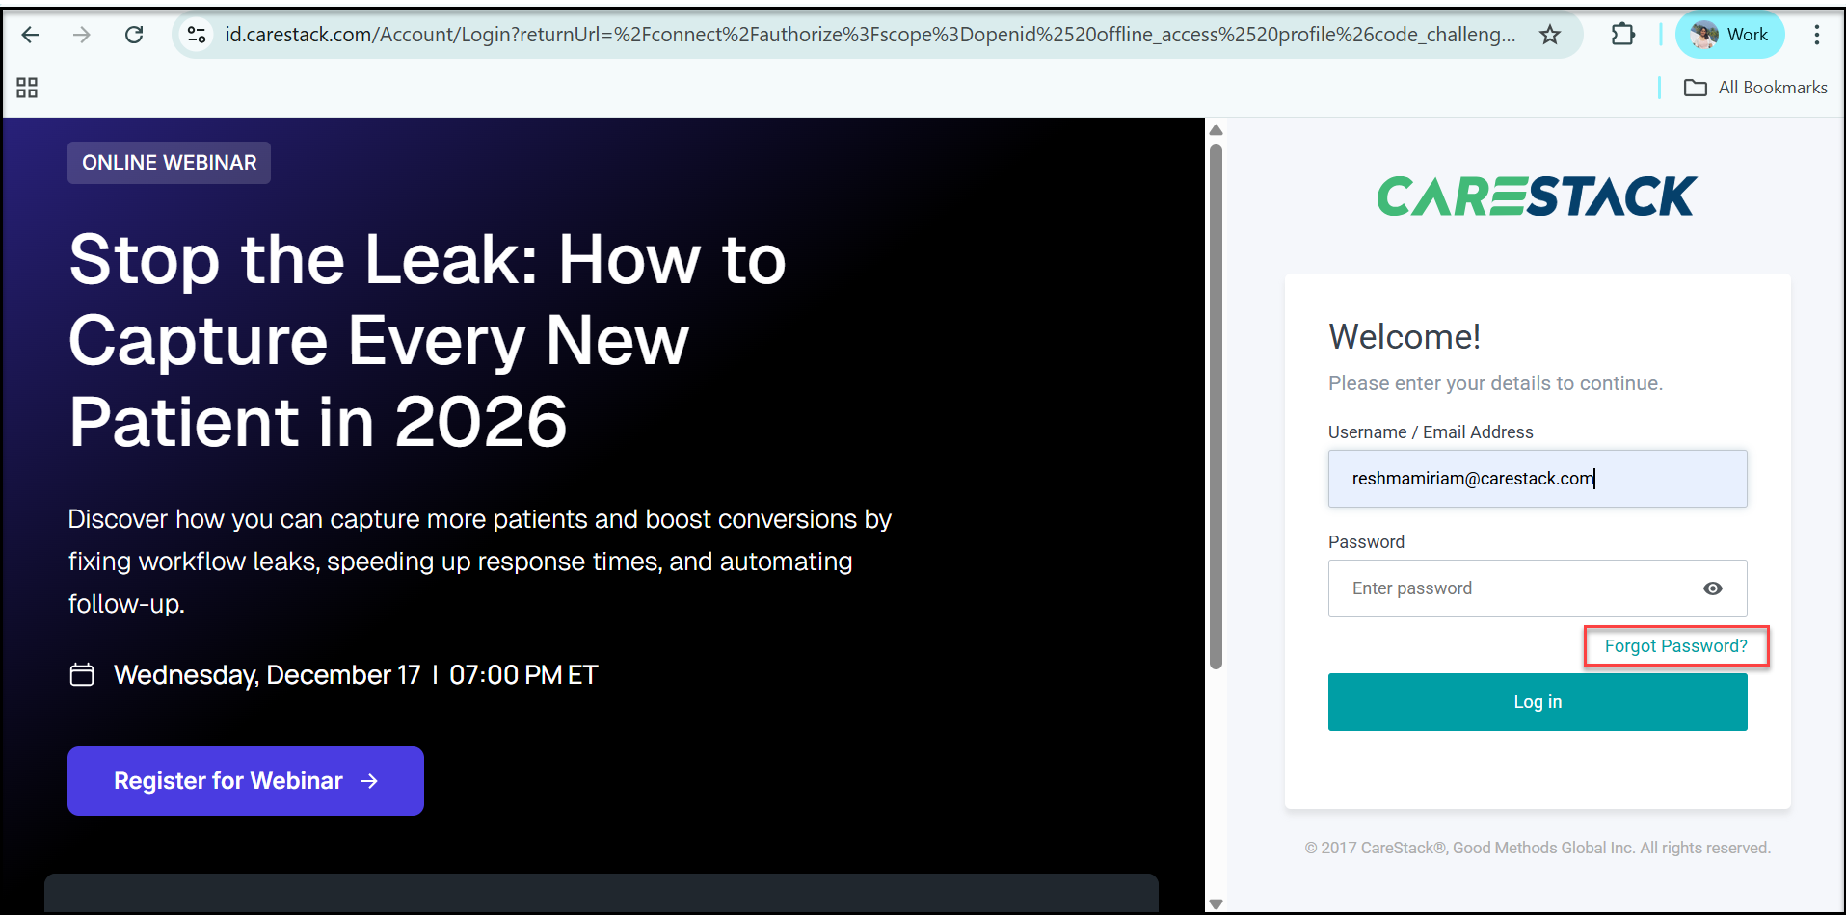

Step 2:
You will be prompted to enter your username or email address associated with your account.
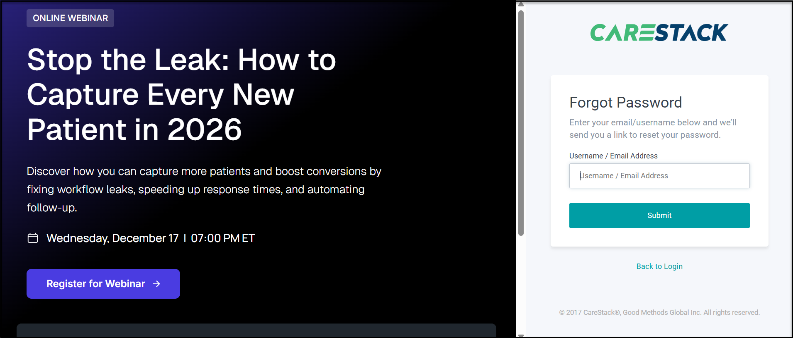

Step 3:
An email containing a password reset link will be sent to the address you provided.


Step 4:
Open your registered email.Please check your inbox (and spam folder if required!).
Click the “Reset Password” button (as shown below). This will take you to a password reset page.
Follow the on-screen instructions to create a new password.
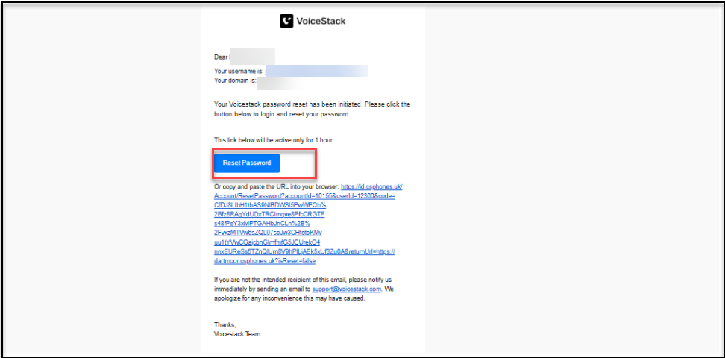
Note: The reset link will remain active for 1 hour and will expire afterwards.

Step 5: All set! Once you have successfully reset your password, log in to VoiceStack using your newly created password.

